DESCRIPTION OF THE BASE MODEL AND MODEL EXTENSIONS

Base model

The original model by Figueiredo and Pereira (2011), which we build on, was developed to explore migration, farmland abandonment, and forest growth as an integrated socio-ecological system, and the conditions affecting bistability and irreversibility (see Table 1 in the main text for a description of all the parameters)

**Table 1:** Variables and parameter description and range in the model. Variables are in majuscule, parameters in minuscule.

|  |  |  |  |  |  |
| --- | --- | --- | --- | --- | --- |
| Symbol | Name in *R* | Meaning | Unit | Range | Default value |
| F | Fo | Forest share of total area (1-F is farmed share of total area) | Proportion of total area [dimensionless] | [0-1] | (dynamic) |
| M | M | Migrants share of total population (1-M is resident share of total population) | Proportion of total population [dimensionless] | [0-1] | (dynamic) |
| μ | miu | Threshold level of M leading to a decision to migrate, average for the entire population (share of total population) | Proportion of total population [dimensionless] | [0-1] | (dynamic) |
| ε | eps | Forest growth rate (exogenous only in the original model) | yr-1 | [0-1] | 0.05 |
| λ | lam | Deforestation rate | yr-1 | [0-1] | 0.05 |
| ω | ome | Probability to take a decision about migration (scales the CDF) | Proportion of total population [dimensionless] | [0-1] | 0.1 |
| s | s | Proportional to variance of the threshold | dimensionless | [0-1] | 0.05 |
| γ | gam | Urban utility | utils/yr  ~~/person~~ | [0-?) | 1 |
| *h* | h | Agricultural utility | utils/yr  ~~/area~~ | [0-?) | 1 |
| *p* | p | Share of urban utility sent as remittances | Proportion of utils [dimensionless] | [0-1] | 0.1 |
| *k* | k | Cost of hired labor | utils-1 | (0-?) | 5? |
| β | bet | Share of remittances used for consumption (vs. hiring labour) | Proportion of utils [dimensionless] | [0-1] | 0.5 |
| φ | phi | Degree of depensory | dimensionless | [0-?) | 8? |

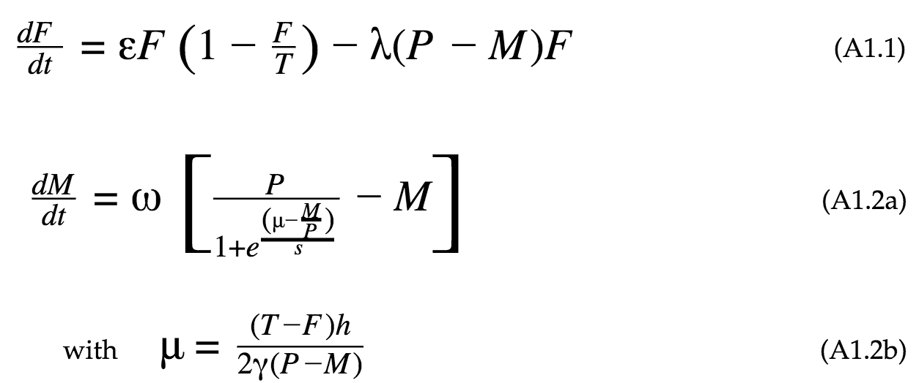

The ecological model (Eq. 1) consists of two processes: logistic growth and land clearing. Forest (*F*, the state variable) grow at a rate (ε) limited by the total area (*T*). Land clearing depends on the number of residents (*R*), the capacity of each individual to carry out this action (λ), and the amount of forest available. Since *R* is equal to the total population (*P*) minus migrants (*M*), forest dynamics are directly affected by migration dynamics. In the socio-economic model (Eq. 2), migration (*M*, the state variable) is a function of the fraction of the population which has migrated (*M/P*), where *P* is the total population. The underlying idea is that individuals have a ‘threshold’ value of *M/P*, above which they will decide to migrate to the city. At the aggregate level, the share of the population that has a threshold below the value of *M/P*, is the share of the population that decides to migrate. This share is given by the cumulative distribution function (CDF) of the logistic distribution (based on an assumption of the distribution of the threshold value among the population). Subtracting the share which has already migrated (*M/P*) from the CDF, times the total population size (*P*), the share of the population who, *if making a decision*, would choose to migrate is calculated. This share is then scaled by a constant representing the probability per unit time of individuals who are *actually* *making a decision* of whether or not to migrate (ω). The CDF is a function of the parameters of the logistic distribution: 1) the mean (μ), which represents the average ‘threshold’ of the population (i.e. average value of *M/P* that triggers a decision to migrate among individuals of the population); and 2) a constant (*s*)which is proportional to the variance of migration thresholds among individuals of the population. The parameter *s* represents the ‘social bonding’ or the aggregate level of ‘conformity’ to group behavior. The population’s mean threshold for choosing to migrate (μ) is defined by the ratio of urban utility per capita (γ) and the agricultural utility per unit area (*h*). When the utility perceived by an individual in the city and in the countryside are the same (γ=[(T-F)*h*]*/*[P-M]) it is assumed that μ is equal to 0.5. That is, when there is no monetary/economic reason to choose to migrate or not to migrate, then it is only the social aspect that determines this decision, and assuming a normal distribution of this threshold values in the population, the mean should be 0.5. Then μ can be replaced (Eq. 2b) in order to couple the socio-economic model to the ecological model: the economic monetary/economic incentives to migrate are shaped by the agricultural area (*A*), which is equal to T minus F.

### Model extension

#### Remittances

Remittances are a primary link between migration and sending regions, and their role for economic development has been one of the most researched topics related with migration. But remittances can be used in very different ways by rural households, either to supplement income for consumption, replacing labor lost to migration with hired labor, or investment in productive activities (whether in- or off-farm). In aggregate, these decisions should reflect at the landscape scale with changes in the agricultural and forest cover. In this paper we focus on two broad possible uses of remittances: consumption and hired labor.  Building on the original Figueiredo and Pereira model (2011), we incorporate terms to represent the remittances sent by migrants in both the forest change and migrant stock change equations (Eq. 1 and 2, respectively), as a proportion (*p*) of the urban utility (γ) obtained by the migrant stock (M). The term β is used to represent the use of remittances: When β = 1, all of the remittances are used by households to supplement income for consumption, and when β = 0 all remittances are used to hire labor. Any value between 0 and 1 represents a mixed use. In the forest change equation (Eq. 1), the term *k* is used to convert utility/income to resident equivalent labor.  In the migrant stock equation (Eq. 2), only the population's average threshold migrating (μ, Eq. 2b) has been modified from the original model. It incorporates the β and *p*, as explained before. We have also simplified the original model by representing Forest (*F*) and Migrant population (*M*) as fractions of the total area and total population. Hence the area in agriculture equals 1 - *F* (the area not covered by forest), and the resident population equals 1 - *M* (the population that has not migrated).

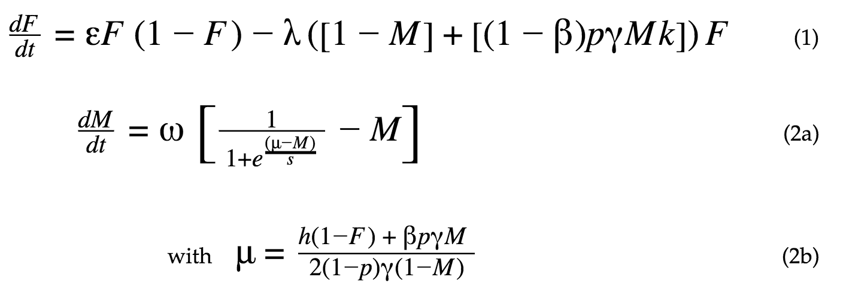

#### Ecology: slow regrowth

Having incorporated remittances to the model, we then propose a modification to the ecological dynamics by introducing a function that represents depensation at low levels of forest cover. There is evidence of depensatory dynamics for different type of animal and plant populations (Liermann and Hilborn 2001).

